United States Patent and Trademark Office
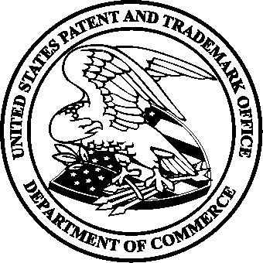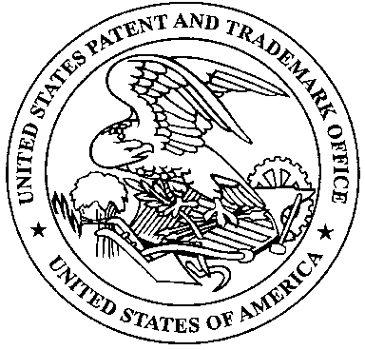

Commissioner for Patents
United States Patent and Trademark Office
P.O. Box 1450
Alexandria, VA 22313-1450
www.uspto.gov

MEMORANDUM

DATE: November 7, 2005

TO: Technology Center 1600

FROM: Jasemine C. Chambers, George Elliott, and Bruce Kisliuk
Directors, Technology Center 1600

SUBJECT: Selection of New Patent Examining Managers

We are pleased to announce the following new managers in TC1600. Please join us in congratulating these employees in their new positions.

Anne Marie Grunberg, Primary Examiner from Art Unit 1661, has been selected as the SPE for Art Unit 1638 and 1661. A veteran of the U.S. Army, Anne Marie used the Army College Fund and GI bill to obtain a B.S. from the University of Maryland where she graduated cum laude and was Class Valedictorian. She went on to receive her M.S. at the University of Maryland in agronomy where she specialized primarily in genetics and molecular marker technology. Anne Marie joined the USPTO in 1998 and became a Primary Examiner in 2003. She worked with the Deputy Commissioner for Patent Examination Policy, Steve Kunin to develop a rejection and Examiner’s Answer on a case of first impression regarding plant patent novelty issues. She has represented the USPTO to various national and international interests including CIOPORA, UPOV, and AAAS. She has examined patent applications drawn to plants, plant breeding, plant transformation, tissue culture, bio- and phyto- remediation, and other areas.

Shaojia Anna Jiang, Primary Examiner from Art Unit 1617 has been selected as the SPE for Art Unit 1623. Anna obtained her Ph.D. in Organic Chemistry from Purdue University. After finishing her post-doctoral fellowship at Rutgers University in New Jersey, Anna worked first at Schering-Plough Research Institute in New Jersey as a synthetic chemist, then at Wyeth-Ayerst Research in New Jersey as a medicinal chemist. Anna joined the USPTO in September 2000 and became a primary examiner in September 2004. She has been examining applications directed to pharmaceutical compositions or formulations comprising a chemical compound(s) with great diversity of chemical structures and methods of treatments; drug delivery systems and pharmaceutical kits; and cosmetic compositions or formulations and methods of use.

Michael Hartley, Primary Examiner from Art Unit 1618, has been selected as a SPE in Art Unit 1618. Michael earned a BS in Biochemistry and Biophysics from the University of Pittsburgh in 1988. He worked in the Transplant Immunology Laboratory at the University of Southwestern Medical Center at Dallas from 1988-1990 performing clinical and research assays for human lymphocyte antigen tissue typing and donor-recipient crossmatching. In 1990, he joined the Transplant Immunology Laboratory at the Medlantic Research Institute in Washington, DC, which supports the organ transplant programs at numerous area hospitals. Michael joined the USPTO in July 1995 and became a Primary Examiner in January 2001. He examines in the area of in vivo contrast agents and methods of diagnostic imaging.

Terry McKelvey, Primary Examiner from Art Unit 1636, has been selected as the SPE for Art Unit 1655. Terry obtained his Ph.D. in microbiology from Duke University performing research on transcriptional regulation of poxvirus early genes. From 1992 to 1994 he studied transformation of cells by an insect virus as a postdoctoral research associate in the Insect Biocontrol Laboratory at the Agricultural Research Service, Beltsville, Maryland. Terry joined the USPTO in August 1994 and progressed to Primary Examiner in June 1998. He has examined patent applications drawn to transcription factors and transcriptional regulation, assays, and systems.

The following manager reassignments are also effective November 13, 2005.

James Wilson, SPE in 1623, reassigned as SPE in 1624.
Andrew Wang, SPE in 1639 and 1661, reassigned as SPE in 1635 and 1639.

